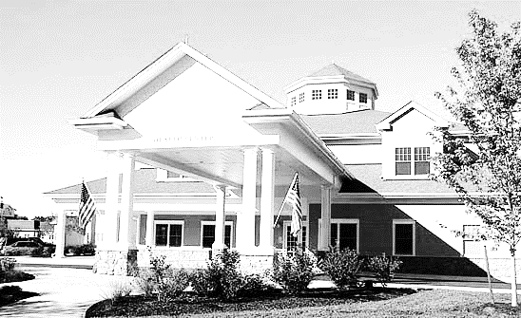

***During your visit*:**

* **Sanitize your hands immediately at the onset of your visit and right before your departure. (*Alcohol hand gel will be provided*).**
* **Please try and follow the recommendations we made above. We are not permitted by NYS Department of Health to require advance testing nor vaccination of any guest. So, we must rely on each individual to help us keep our staff and residents virus and illness free.**

***General Information*:**

* **Visits available 7 days per week, 24 hours per day**
* **There are currently no limits on number of visitors,**

**however, we do ask you to keep the following**

**recommendations in mind during your visit:**

* + **It is safest if you keep 6+ feet of distance**
  + **It is safest if you wear your mask the whole time**
  + **It is safest if you do not visit if you have been**

**exposed or could have been exposed**

***Upon Arrival:***

* **You will be screened at the Reception Desk**
* **Visitors will be required to submit the completed Covid19 screening and tracing form that we will provide and is available on our website.**
* **Visitors will be screened, including temperature check upon arrival.**
* **We do not presently have available rapid or PCR tests to offer to visitors, so testing before your visit would be your option to do offsite. It’s a great idea, if you can access an advance test.**

*WPNP VFS 20-8*

***\*Per regulatory mandate, failure to comply with any of the following requirements will result in suspension of any visitation rights throughout the pandemic.***

**Woodland Pond Health Center Visitation Fact Sheet**

***After your visit:***

* **If you develop any symptoms of illness during the next 14 days after your visit, you must notify Woodland Pond infection control team, by calling the reception desk at ext. 5910 and asking to speak with nursing administration.**